

Project Name: Electronic Library Management System

**Project Members:**

1-Abdallah Samir Elsayed Elsharkawy

1. Abdellatif Osama Abdellatif Amer
2. Hagag Fawzi Hagag
3. Abdallah Mohamed Abdellwahab Elghonemy
4. Maha Samir Mekawy
5. Abdelrahman Maged Elsayed

**Use Case:**

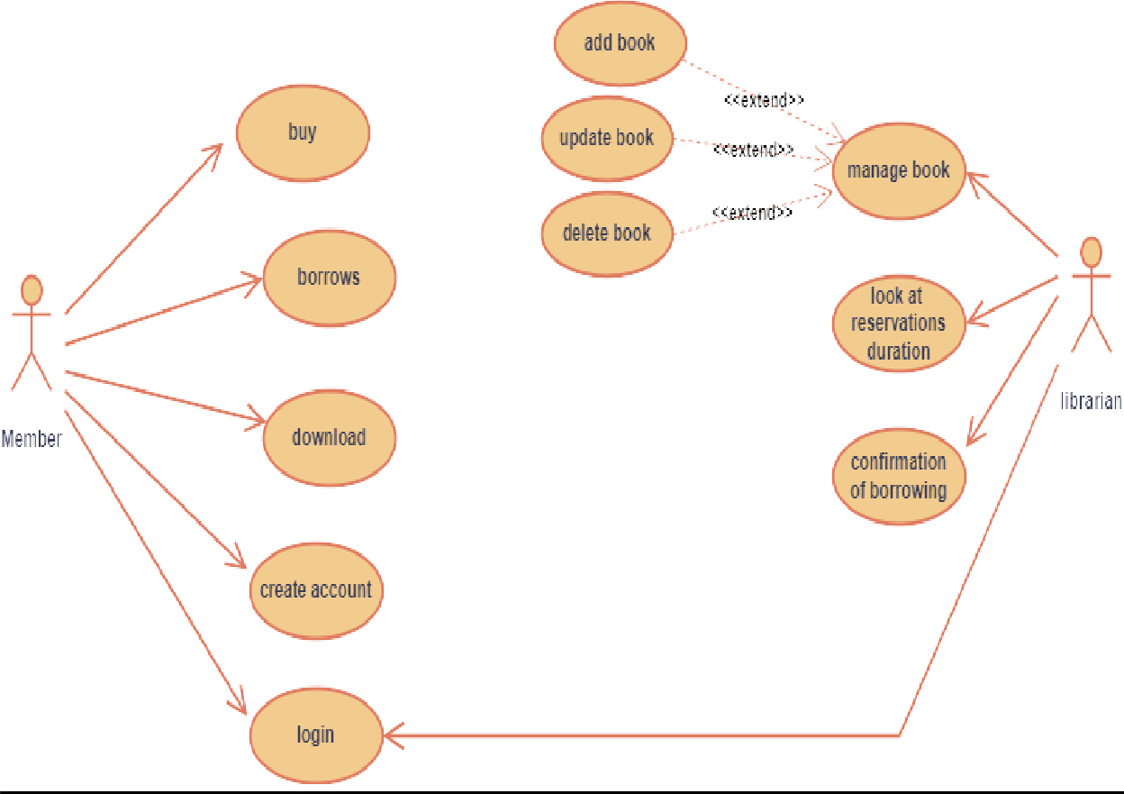

|  |  |
| --- | --- |
| **Use Case Name:** | Buy a book |
| **Actors:** | Users |
| **Preconditions:** | 1. user has active account with **Library website.** 2. user has an activated ATM card. 3. Vodafone Cash Transfer Number. |
| **Postconditions:** | **Message:** Book Purchased Successfully |
| **Normal Flow:** | * From Home Page Select the book to be. * Click on buy. * Check Availability of a book * Choose a payment method. * Enter the payment code according to the chosen method. * Arrival of the confirmation message on the Purchase |
| **Alternative Flows:** | **During Purchase:**  **-** If a book not Available, Add a book to on demand list. |
| **Exceptions:** | **During Purchase:**   * a user doesn’t have enough money. * the ATM Card is not Activated. |

|  |  |
| --- | --- |
| **Use Case Name:** | Borrow a book |
| **Actors:** | Users |
| **Preconditions:** | user has active account with **Library website.** |
| **Postconditions:** | **Message:** Book Borrowed Successfully |
| **Normal Flow:** | * From Home Page Select the book to be. * Click on Borrow. * Check Availability of a book * Arrival of the confirmation message on the Borrow |
| **Alternative Flows:** | **During Borrow:**  **-** If a book not Available, Add a book to on demand list. |
| **Exceptions:** | **During Borrow:**  **-** The User is not Verified for borrowing. |

|  |  |
| --- | --- |
| **Use Case Name:** | Login |
| **Actors:** | Users |
| **Preconditions:** | user has active account with **Library website.** |
| **Postconditions:** | **Message:** Login Done Successfully |
| **Normal Flow:** | * From Account Page Select the book to Login. * Enter Username and Password * Check if the Username and Password is Correct * Go to Home Page |
| **Alternative Flows:** | **During Login:**  **-** If a User doesn’t have an account, he must create one. |
| **Exceptions:** | **During Login:**  **-** Incorrect Password and Username |

|  |  |
| --- | --- |
| **Use Case Name:** | Register |
| **Actors:** | Users |
| **Preconditions:** | * The user must have a valid phone number. * The User must have a national ID that is not Expired. * Enter the other Required Fields. |
| **Postconditions:** | **Message:** Register Done Successfully |
| **Normal Flow:** | * From Account Page Select Register. * After Entered the Required Fields Click Submit. * Go to Login Page |
| **Alternative Flows:** | **During Register:**  **-** If a User have an account, he must Login. |
| **Exceptions:** | **During Register:**  **-** Not All Fields Completed |

|  |  |
| --- | --- |
| **Use Case Name:** | Download |
| **Actors:** | Users |
| **Preconditions:** | * Select The Required Book * Pay money for the required book. * Click on download Button |
| **Postconditions:** | **Message:** File downloaded Successfully |
| **Normal Flow:** | * Select The Required Book * Click on download Button. |
| **Alternative Flows:** |  |
| **Exceptions:** | **During Download:**   * Book is not selected. * Server is not running |

|  |  |
| --- | --- |
| **Use Case Name:** | Confirm of Borrowing |
| **Actors:** | Librarian |
| **Preconditions:** | **-** The Existence of Borrow request. |
| **Postconditions:** | **Message:** Borrow is Done Successfully |
| **Normal Flow:** | * Look at Reservation request. * Check Availability of a book. * Confirm a Borrow. |
| **Alternative Flows:** | **During Confirmation:**  **-** Send a message that informs user that a book is not found. |
| **Exceptions:** | **During Confirmation:**  **-** User cancel the request |

|  |  |
| --- | --- |
| **Use Case Name:** | Look at Reservation Duration |
| **Actors:** | Librarian |
| **Preconditions:** | **-** The Existence of reservation Requests |
| **Postconditions:** | knowledge of reservation Durations |
| **Normal Flow:** | * Look at Reservation Duration Table. * If the duration is end, Text the Borrower. |
| **Alternative Flows:** | **During exploring Reservations:**  **-** The user request to extend his borrow Duration |
| **Exceptions:** | **During exploring Reservations:**  **-** The user borrowing duration is end but he does not extend it |

|  |  |
| --- | --- |
| **Use Case Name:** | Manage book |
| **Actors:** | Librarian |
| **Preconditions:** | * Librarian must be login into the system. * select one book at least. |
| **Postconditions:** | transfer into page that can select operation from it on book. |
| **Normal Flow:** | * select one from 3 operations (update, delete, add) book. |
| **Alternative Flows:** | - |
| **Exceptions:** | does not select any book. |

|  |  |
| --- | --- |
| **Use Case Name:** | Add book |
| **Actors:** | Librarian |
| **Preconditions:** | **-** Librarian Have Book info to Add |
| **Postconditions:** | **Message:** Book is Added Successfully |
| **Normal Flow:** | * Add Book Required Fields. * Upload the book as PDF. * Click on Add Button. |
| **Alternative Flows:** | The book has been found Before, go to see it’s info |
| **Exceptions:** | **During Login:**  Not all Fields Were Added. |

|  |  |
| --- | --- |
| **Use Case Name:** | Update book |
| **Actors:** | Librarian |
| **Preconditions:** | **-** The book has been found in system |
| **Postconditions:** | **Message:** Book is Updated Successfully |
| **Normal Flow:** | * Add Updated Book Required Fields. * Upload the book as PDF as Updated. * Click on Update Button. |
| **Alternative Flows:** | - |
| **Exceptions:** | **During Update:**   * Not all Fields Were Added. * The Required book for updated is not found. |

|  |  |
| --- | --- |
| **Use Case Name:** | Delete book |
| **Actors:** | Librarian |
| **Preconditions:** | **-** The book has been found in system |
| **Postconditions:** | **Message:** Book is Deleted Successfully |
| **Normal Flow:** | * enter The Book Id to find book to delete. * Delete The Book. * Click on Delete Button. |
| **Alternative Flows:** | - |
| **Exceptions:** | **During Delete:**   * The Required book for Delete is not found. * The book as Reservation Duration. |

**Activity Diagram For A System**

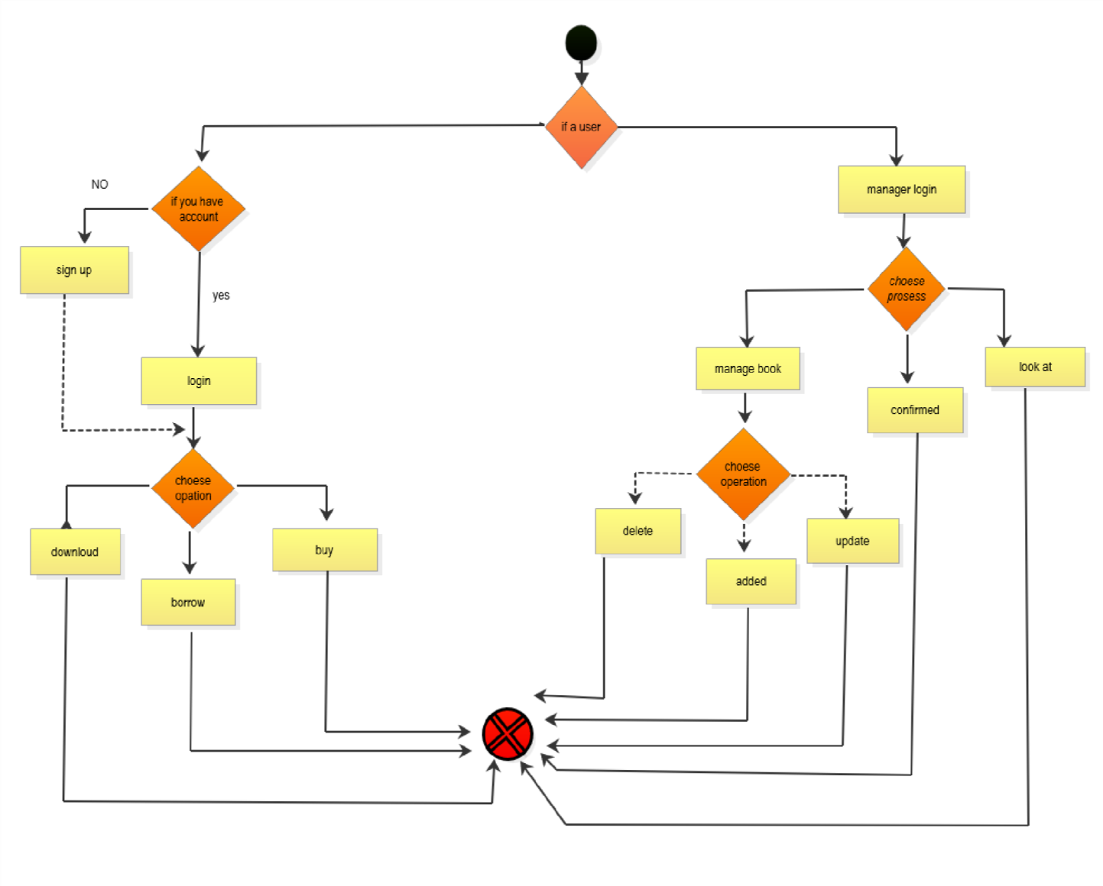

**Activity diagrams**

Sign up



choose is admin or user

enter username

enter password

confirmpasswo rd

enter email

enter phonenumber

sunmit

set of database

Login



sign_up

is there an account

sign up

enter username

enter password

check vailddata

login issuccessful

buy



login

enter a bookname

is there abook

request tolibrarian

trackcomplaint s

show book

pay price

credit card

correct pin and ismoney enough

confirm buy abook

vodafone cash

correct phone number and ismoney enough

download

borrow

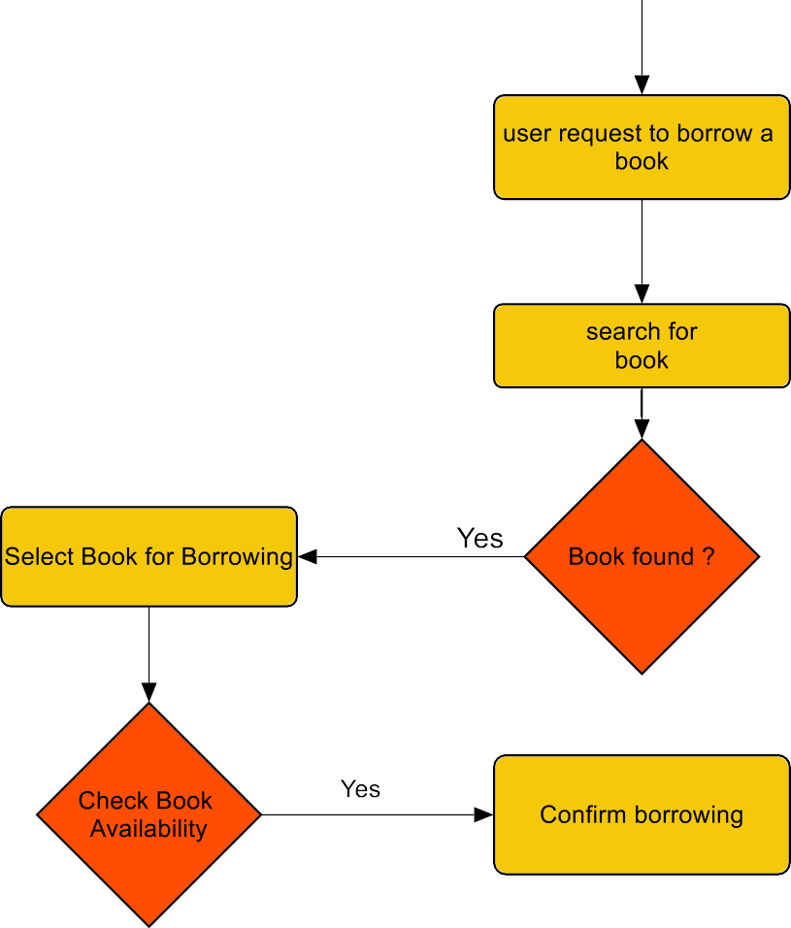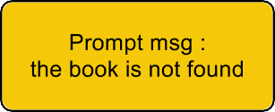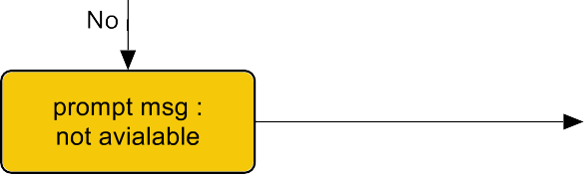

Download



buy

select a book

is bookavail able

cancel

click

ofdownload

select alocation

Manager login



is there anaccount

enter managername

enter password

verify managername andpassword

check vaild data

success login

Manage book



manager login

active asystem

open database

delete

choose anoperation

add

update

add

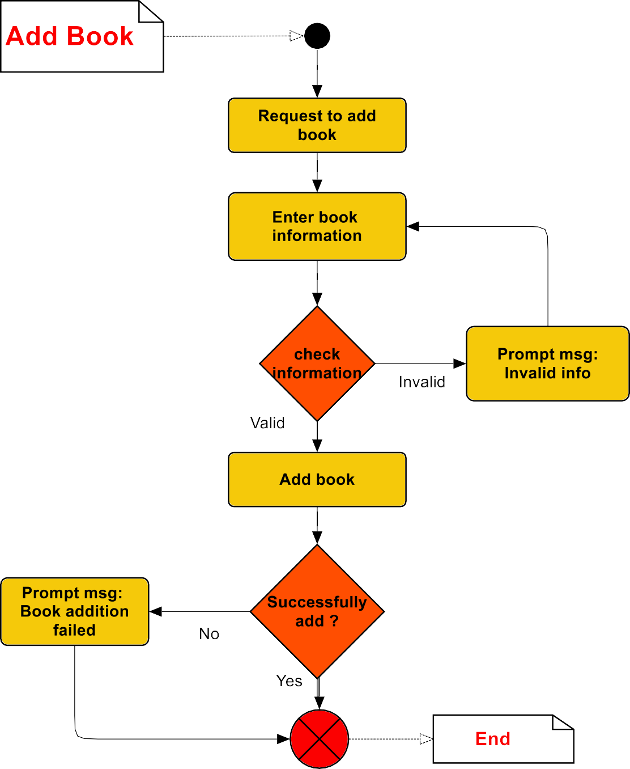

Update

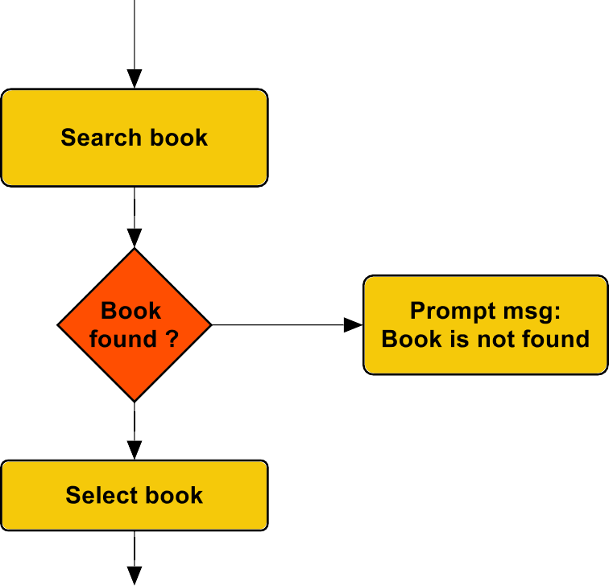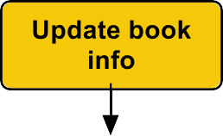

Delete

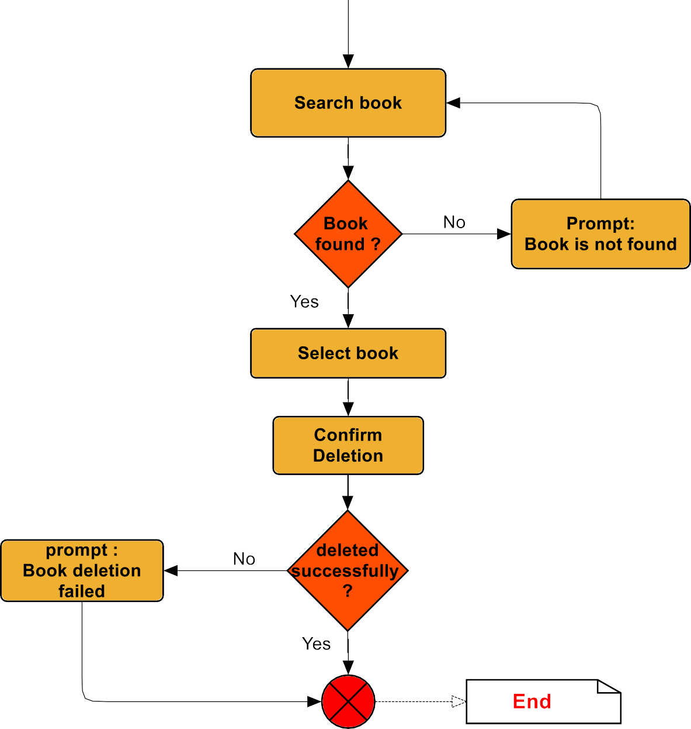

Look at



know Booksthat have beenborrowing

number ofbooks <5

request a addbooks to thesystem

Confirm







know Booksthat have beenborrowing

number ofbooks <5

request a addbooks to thesystem



**Class Diagram**

